Info:
LLM-as-judge: unsloth/Phi-4-bnb-4bit
The dataset contains 385 questions, all models be tested will use the same dataset.
The score of each indicator will set between 0 and 1, and the higher score stands for better performance on each test case.
#The model used as judge has only 140 billion parameters, which is not sufficient and shall never be considered as a formal benchmark but simply a reference.
==================================================
Description to each indicator as follow:
#All the descriptions are from the official website of RAGAs
-------------------------------------------------------------------------------
Faithfulness:
The Faithfulness metric measures how factually consistent a response is with the retrieved context. It ranges from 0 to 1, with higher scores indicating better consistency.
A response is considered faithful if all its claims can be supported by the retrieved context.
To calculate this: 1. Identify all the claims in the response. 2. Check each claim to see if it can be inferred from the retrieved context. 3. Compute the faithfulness score using the formula:
https://docs.ragas.io/en/stable/concepts/metrics/available_metrics/faithfulness/
-------------------------------------------------------------------------------
LLM Context Precision:
Context Precision is a metric that evaluates the retriever's ability to rank relevant chunks higher than irrelevant ones for a given query in the retrieved context. Specifically, it assesses the degree to which relevant chunks in the retrieved context are placed at the top of the ranking.
It is calculated as the mean of the precision@k for each chunk in the context. Precision@k is the ratio of the number of relevant chunks at rank k to the total number of chunks at rank k.
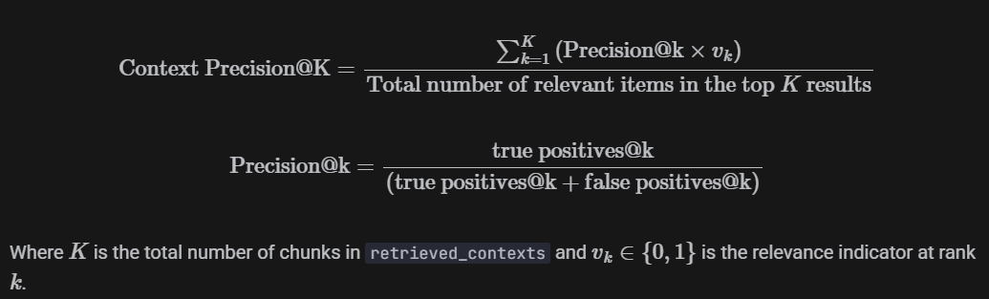
https://docs.ragas.io/en/stable/concepts/metrics/available_metrics/context_precision/
-------------------------------------------------------------------------------
Answer Relevancy:
The Answer Relevancy metric measures how relevant a response is to the user input. It ranges from 0 to 1, with higher scores indicating better alignment with the user input.
An answer is considered relevant if it directly and appropriately addresses the original question. This metric focuses on how well the answer matches the intent of the question, without evaluating factual accuracy. It penalizes answers that are incomplete or include unnecessary details.
This metric is calculated using the user_input and the response as follows:
- Generate a set of artificial questions (default is 3) based on the response. These questions are designed to reflect the content of the response.
- Compute the cosine similarity between the embedding of the user input (E_o) and the embedding of each generated question (E_{gi}).
- Take the average of these cosine similarity scores to get the Answer Relevancy:
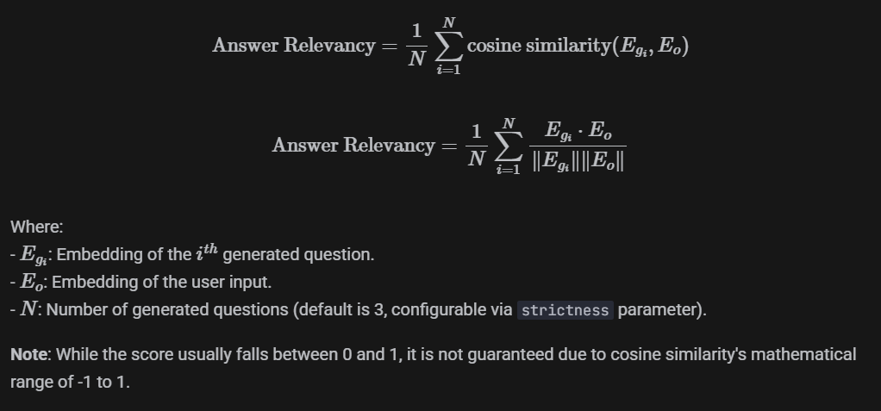
https://docs.ragas.io/en/stable/concepts/metrics/available_metrics/answer_relevance/
==================================================
Meta/Llama-3.1-8B-AWQ
------------------------------------------------------------------------------
Average Score:
Faithfulness: 0.8301 (Fail: 1, question idx = 333)
Answer Relevancy: 0.8133 (Fail: 1, question idx = 333)
LLM Context Precision (W/O reference): 0.8201 (Fail: 0)
==================================================
Qwen/Qwen3-8B-AWQ (thinking mode off)
------------------------------------------------------------------------------
Average Score:
Faithfulness: 0.8454 (Fail: 0)
Answer Relevancy: 0.8375 (Fail: 0)
LLM Context Precision (W/O reference): 0.8390 (Fail: 0) ==================================================
Qwen/Qwen3-8B-AWQ (thinking mode on)
input tokens: 2579296 | output tokens: 306194
------------------------------------------------------------------------------
Average Score:
Faithfulness: 0.8406 (Fail: 0)
Answer Relevancy: 0.8123 (Fail: 0)
LLM Context Precision (W/O reference): 0.8234 (Fail: 0) ==================================================

